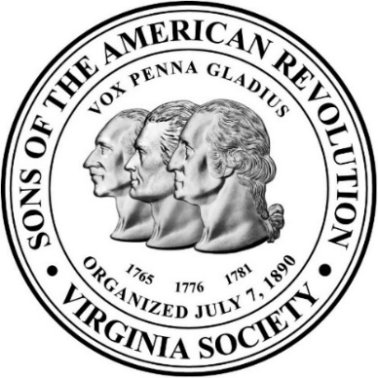 | Virginia Society
 | Sons of the American Revolution
 | 136th Annual Meeting Agenda
 | February 6-7, 2026

Virginia Crossings Hotel

1000 Virginia Center Parkway

Glen Allen, Virginia 23059

Friday, February 6, 2025

11:00 – 1:00 pm |  | Executive Committee Meeting | York Room
1:00 pm – 5:30 pm |  | Compatriot & Guest Registration | Henrico Prefunction
12:00 – 3:30 pm |  | Ladies Appreciation Luncheon w/ transportation fm/back Virginia Crossings | Jefferson Hotel,  Richmond, VA
2:00 – 4:00 pm |  | Chapter Scrapbook Contest Judging | Hanover Meeting Room
4:00 pm |  | Hotel Room Check-Ins | Jefferson Building Lobby
4:00 – 5:00 pm |  | Social Gathering (Cash Bar) | Henrico Prefunction
5:00 – 7:00 pm |  | Friday Buffet Dinner: Guest Speaker & Recognitions | Henrico Ballroom
7:00 – 9:00 pm |  | Color Guard Drumhead Muster – Refreshments (All Compatriots Invited) | Henrico Ballroom
7:00 – 9:00 pm |  | Ladies Program (Game Night) | Hanover Room
9:00 – 11:00 pm |  | 105th President’s Reception | Henrico Prefunction
Saturday, February 7, 2025

7:00 – 10:00 am | Compatriot & Guest Registration | Henrico Prefunction
6:30 – 8:00 am | Breakfast on your Own | The Glen Restaurant
8:00 – 10:00 am | General Membership Meeting | Henrico Ballroom
9:00 – 10:00 am | Rumbaugh Contestants Preparation | Chesterfield Meeting Room
10:15 – 12:30 pm | Rumbaugh Orations Contest and Youth with Teacher of the Year Awards Ceremony (Open to All) | Henrico Ballroom
11:00 – 12:00 pm | Rumbaugh Judges Conferment (Closed) | Chesterfield Meeting Room
 | Saturday, February 7, 2025
12:30 – 2:00 pm | Lunch Buffet (Chef’s Choice) | The Glen Restaurant
2:00 – 4:00 pm | Compatriot Memorial Service, Public Service Awards, Virginia SAR Chapter Winners | Henrico Ballroom
4:00 – 4:30 pm | Group Photo of All Attendees  (Henrico Ballroom in case of inclement weather) | Jefferson Bldg. Portico Steps
4:30 – 6:00 pm | Free Time | Virginia Crossings Hotel
6:00 – 7:00 pm | Social Gathering (Cash Bar)  Photo Booth Available | Henrico Prefunction
6:00 – 9:00 pm | Color Guard Prep Room | York Room
7:00 – 9:30 pm | Banquet Dinner: Color Guard Commander Change of Command, State President & Officer Installations & Recognitions (Black Tie or business suit w/ decorations, or colonial attire); Picture of all Virginia SAR First Ladies (Invited) | Henrico Ballroom
9:30 – 11:00 pm | 106th President’s Reception | Henrico Prefunction

Sunday, February 8, 2025

8:00 – 9:30 am | Executive Committee Meeting | York Room
11:00 am | Hotel Room Checkout | Jefferson Building Lobby

(Agenda subject to change)

