**Martin’s Station Chapter**

**Virginia Society Sons of the American Revolution**

Ewing, Virginia

**Invites you to participate in the New Celebration**

***Honoring the Pioneers and Patriots of the***

***Wilderness Road***

**Held during the park’s May event – Virginia: America’s First Frontier**

**May 12th-May 14th 2023**

**Daily Events**:

***Friday: 9-5 ; Saturday: 10-5; Sunday : 10-3***

Admission: $10 per vehicle; $4 per vehicle Sunday

***SAR, DAR, CAR and other Societies and Chapters are invited to participate in a formal wreath laying ceremony at the Martin Station Monument, Wilderness Road State Park, Ewing, VA. The Ceremony begins at 10 a.m. on May 13, 2023.***

***May 13, 2006.*** 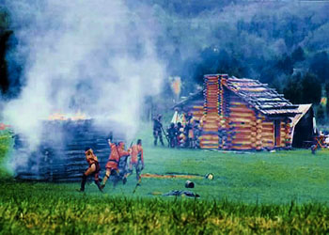

*Participants desiring to present a wreath must deliver it to the appropriate area near the monument not later than 9:30 a.m. on May 13th. Compatriots wearing period, Militia or Continental Line dress are limited to the area in front of Information Center and the SAR Monument. After the wreath laying ceremony, the above are restricted to areas in front of the Information Center in order to be in compliance with WRSP rules. Wreaths may be dedicated to a specific Organization, an individual patriot, or anything else deemed appropriate.*

**It is requested that participants complete and mail your intent no later than**

**April 24, 2023 so that we may get the program to the printers in time. Send to: Thomas Coker, President, Martin Station Chapter, 925 Patriots Road, Ewing, VA 24248,** **[trc@mounet.com](mailto:TRC@Mounet.com) 276-445-5836.**

**T**

**Thomas Coker, President Martin Station Chapter**

**Route 1, Box 71H, Ewing, Virginia 24248**

[**TRC@Mounet.com**](mailto:TRC@Mounet.com) **276-445-5836**

Name of society/chapter/individual_____________________________________________

First Middle Last

Lay wreath at Martin Station Monument? Yes__No__ Who?______________________________

Presenter

Wreath Dedicated To_____________________________________________________________

Bringing unit/Chapter flag? Yes__ No__ Color Guard? Yes__ No__

Number of Members expected to Attend_____ In uniform or colonial dress_________

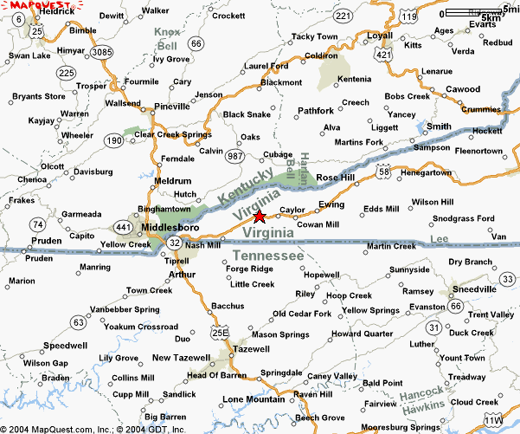

Map with Star* indicates general location of Wilderness Road State Park (WRSP) on US 58 near Ewing, VA. The Cumberland Gap National Historic Park is near the intersection of US25E and US 58.

**Lodging accommodations near WRSP include**:

**Econo Lodge *Cumberland Gap Nat’l Hist. Park Jonesville Motor Lodge**

1623 East Cumberland Ave. Box 1848 Highway 58 West

Middlesboro, KY Middlesboro, KY 40965 Jonesville, VA

606-248-5630 606-248-2817 276-346-3210

Approx. 12 West of WRSP Approx. 8 miles West of WRSP Approx. 25 miles East of WRSP

**Holiday Inn Express Cumberland Gap Inn Pine Mountain State Park Resort**

1252 North 12th Street 630 Brooklyn Street 1050 State Park Road

Middlesboro, KY Cumberland Gap, TN Pineville, KY

606-248-6860 423-869-3996 606-337-3066

Approx. 13 West of WRSP Approx. 10 miles East of WRSP Approx. 13 miles North of Middlesboro

**\*** Offers group camping, tent camping, back country camping and RV spaces with electrical hookup.

There are other area accommodations. Please check out information available on the internet.



Please be aware that this event weekend is also usually the time of graduation at the local Lincoln Memorial University, so accommodations may fill up fast, as well as be limited!